
MBAI 5300G
Programming and Data Processing
Final Project
Analyzing airline performance and customer satisfaction analysis
Mohammad Shah, Abdul Wasay, Faria Akther, Sumandeep Kaur*
Abstract
This project investigates the relation between an airline's operational performance metrics and passengers’ satisfaction using an undisclosed large customer satisfaction dataset. The objective is to identify the most influential factors for satisfaction and determine where the airline should redirect its focus for improvements. The​‍​‌‍​‍‌​‍​‌‍​‍‌ dataset consists of ratings ranging from 0-5 for a variety of operational categories, such as in-flight entertainment, seat comfort, cleanliness, etc. After data preparation, correlation analysis, class segmentation, and a decision tree model were used to figure out the main factors that affect customer ​‍​‌‍​‍‌​‍​‌‍​‍‌satisfaction.
The results show that in-flight entertainment, seat comfort, ease of online booking, and on-board service consistently emerge as the strongest predictors of satisfaction, though the relative importance of these factors varies by travel class. Economy passengers value digital convenience, while Eco-Plus travelers value having a balance between comfort and service quality, and Business Class passengers highly emphasize physical comfort and premium in-flight experiences. The Decision Tree Classifier further validates these insights, identifying in-flight entertainment as the most influential factor overall.
Keywords: Airline Service Quality; Customer Satisfaction; Operational Performance; Passenger Experience; Service Factors; Correlation Analysis

- Introduction
Customer satisfaction has become a central priority and concern for airlines operating in a highly competitive and service-driven industry. As passengers' expectations keep on evolving and changing with time, airlines must figure out what factors of their service experience are the most important, and in what way these priorities vary between flight ​‍​‌‍​‍‌​‍​‌‍​‍‌classes.
This report examines a large, undisclosed airline dataset to identify critical factors that shape passengers’ experiences. The analysis focuses on operational and service-related ratings, such as seat comfort, in-flight entertainment, on-board service, and digital booking processes, to evaluate their impact on satisfaction. A combination of exploratory analysis, correlation techniques, class-based comparisons, and machine learning is applied to gain a better understanding of these relationships.
There are three objectives:
- Identify the primary factors that enhance customer satisfaction
- Compare how satisfaction drivers differ across Economy, Eco-Plus, and Business Class passengers
- Highlight service factors that are either highly influential or widely underperforming in passenger ratings, to help identify where improvements would be most impactful
This report provides insights that support data-driven decision-making, as it presents opportunities for airlines to perform targeted improvements in their service that can ultimately strengthen their customer experience and loyalty.
- Literature Review
Research on airline customer satisfaction studies finds service quality as the principal factor influencing the customer experience and satisfaction. Many previous studies become aware of the importance of several service factors, including seat comfort, cleanliness of cabin, interaction with staff, speed of check-in, and in-flight entertainment to the overall customer satisfaction (Archana & Subha, 2012; Park et al., 2006). Operational elements such as baggage handling and online customer support are also important for satisfaction, but their impact can vary greatly between business and economy classes (Chen & Chang, 2005).
There are multiple models to explain the methods used to explain how passengers evaluate airline services. The SERVQUAL Model (Parasuraman, Zeithaml, & Berry, 1988) is one of the most commonly utilized models because it places emphasis on the difference (gap) between expected and perceived service performance, which includes reliability, responsiveness, assurance, and empathy of service. Additionally, the Expectation–Confirmation Theory, which similarly proposes that satisfaction will be enhanced if a customer's actual experience exceeds their expectations that they had before using the airline service (Oliver, 1980). These models highlight why certain service features can have a disproportionately strong effect on satisfaction when delivered well.
More recently, researchers have begun to analyze satisfaction results using data-based and machine learning techniques, including logistic regression, random forest, decision tree, and neural networks (Chung & Hsu, 2015; Abdella et al, 2019). Although these approaches do often provide strong predictive performance, much of the existing literature emphasizes accuracy over interpretability, making it difficult for airline managers to determine practical improvements. Also, many studies analyze passengers as a single group, without examining how the importance of service attributes may differ across classes, such as Business or Economy class.
This project aims to address these gaps by using correlation analysis and decision tree modeling to identify the most significant predictors of customer satisfaction and examine how these predictors vary among the different flight classes, to show where improvements could be made.

- Methodology
The study uses the publicly available “Airline_Customer_Satisfaction” dataset, obtained from Kaggle. The dataset contains 129,880 rows of information with a 0-5 numerical rating scale across various operational service factors, demographic attributes, delay information, and binary satisfaction variables. The dataset presents itself to be suitable for undergoing statistical analysis due to its robust, structured, and numerical-based evaluations across operational categories for an airline.
The data is derived from an airline customer satisfaction survey in which passengers were asked to evaluate their flight experience for each factor. With the data collected being subjective to each participant of the survey, the similarities amongst the rating scale and the large volume of responses supports the reliability of the dataset and creates a strong foundation for analysis.
A series of steps were taken for cleaning and preparation to ensure data accuracy and readiness for analysis to begin. All variables were evaluated for missing entries, where the variable” Arrival Delay in Minutes” contained 393 missing entries. This issue was addressed through the use of median imputation to reduce the influence of extreme delay values. Next, the satisfaction category was encoded from its original categorical state of “satisfied” or "dissatisfied" to a binary numerical variable. To deepen the degree of analysis, the data was broken into subsets based on travel class, representing business, economy plus, and economy passengers. Subsetting by class allowed for a new perspective to emerge that could be compared against the other classes and the overall dataset itself.
The analysis involved performing descriptive analysis, which included seeing the percentage of satisfied vs dissatisfied, and the satisfaction distribution across different classes. The data was then segmented by travel class to compare patterns across Economy, Eco-Plus, and Business Class. Next, a correlation of service factors and satisfaction was done to identify the strongest operational predictors of satisfaction. This was done for the overall dataset and then for each passenger class sub-dataset. Next, an average rating service factor analysis was also done in the same manner. Finally, a decision tree classifier was applied to predict satisfaction and determine feature importance, confirming that factors such as in-flight entertainment, seat comfort, and ease of online booking were the most influential drivers of customer satisfaction.
Visualization was used to aid in interpretation of these findings. Firstly, a pie chart was used to visualize the overall distribution of satisfied and dissatisfied passengers. Next, correlation matrix heat maps were used to identify patterns among service factors. Furthermore, colour-coded bar charts were used to represent the correlation of each factor against satisfaction, as well as displaying the average rating of each factor. This was then followed by a decision tree classifier to highlight the key paths and the most influential factors in predicting satisfaction.
- Data Analysis
The​‍​‌‍​‍‌​‍​‌‍​‍‌ analysis started with a thorough check of the dataset to confirm that it was appropriate for modeling and drawing conclusions. Data processing involved looking over the dataset structure, which contained 129,880 records, and verifying that there were no missing values. Some data cleaning was required, as missing values in "Arrival Delay in Minutes" were filled with the median in order to keep the general distribution intact. The satisfaction variable was changed to a binary numeric form (satisfaction_num), thus 1 stood for a satisfied state and 0 for a dissatisfied ​‍​‌‍​‍‌​‍​‌‍​‍‌state (being dissatisfied). Afterwards, the analysis illustrated the distribution of satisfied and dissatisfied passengers, as well as the variation in satisfaction levels across different flight classes, through graphical visualizations.
Figure 1
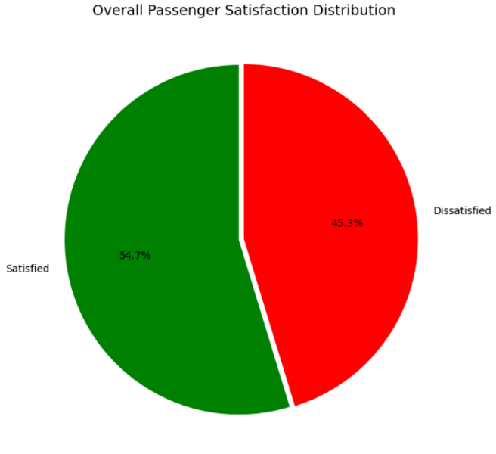

Fig. 1. Pie chart illustrating the overall satisfaction distribution of the dataset.

Figure 2

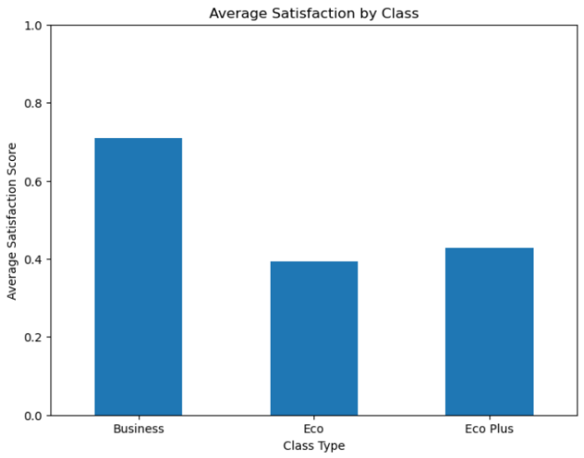
Fig. 2. Bar chart illustrating satisfaction distribution levels across different flight classes.
  - Correlation of Factors with Satisfaction: Overall Dataset, and for Each Sub-Dataset
To allow for class-based comparisons for further analysis, the dataset was also divided into Economy, Eco-Plus, and Business Class subsets. After dividing the dataset, correlation analysis was done to see the relationship between service factors and customer satisfaction for the overall dataset, and for each sub-dataset: Economy, Eco-Plus, and Business.
For the overall dataset, the analysis revealed several strong relationships, as the most influential factors were in-flight entertainment, ease of online booking, and online support. These findings highlight the importance of both in-flight experience and digital service experience for customers. In addition, features such as gate location, food/drink, and in-flight Wi-Fi displayed weak correlations with satisfaction, suggesting they play a limited role in shaping passenger expectations.

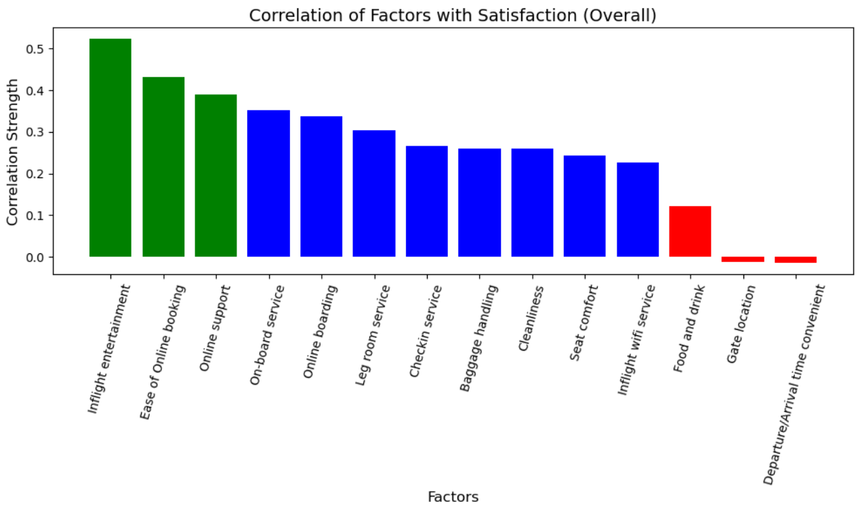
Figure 3
Fig. 3. Bar chart illustrating the correlation of factors with satisfaction across the entire dataset (overall).
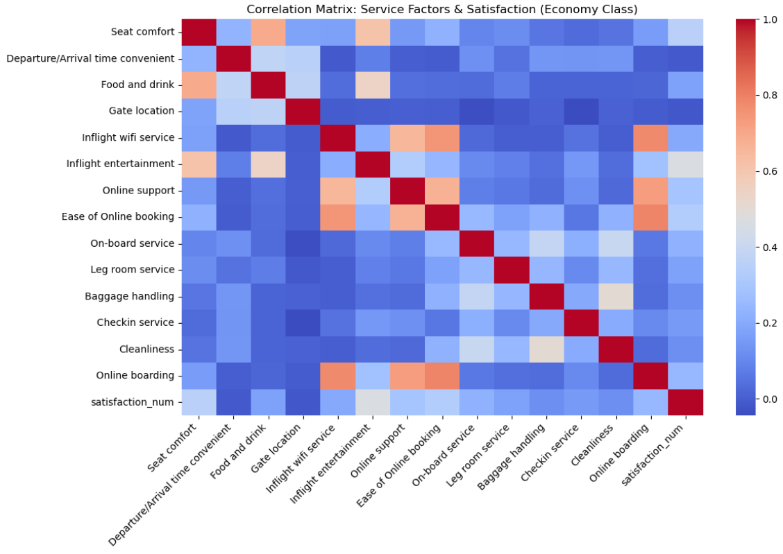
To explore whether different passenger groups value different aspects of service, separate correlation matrices and bar graphs were created for each sub-dataset. These visualizations showed meaningful differences across the classes, which suggests that Figure 4
Fig. 4. Correlation matrix for economy class.

uniform service improvements may not be equally effective across all passengers.

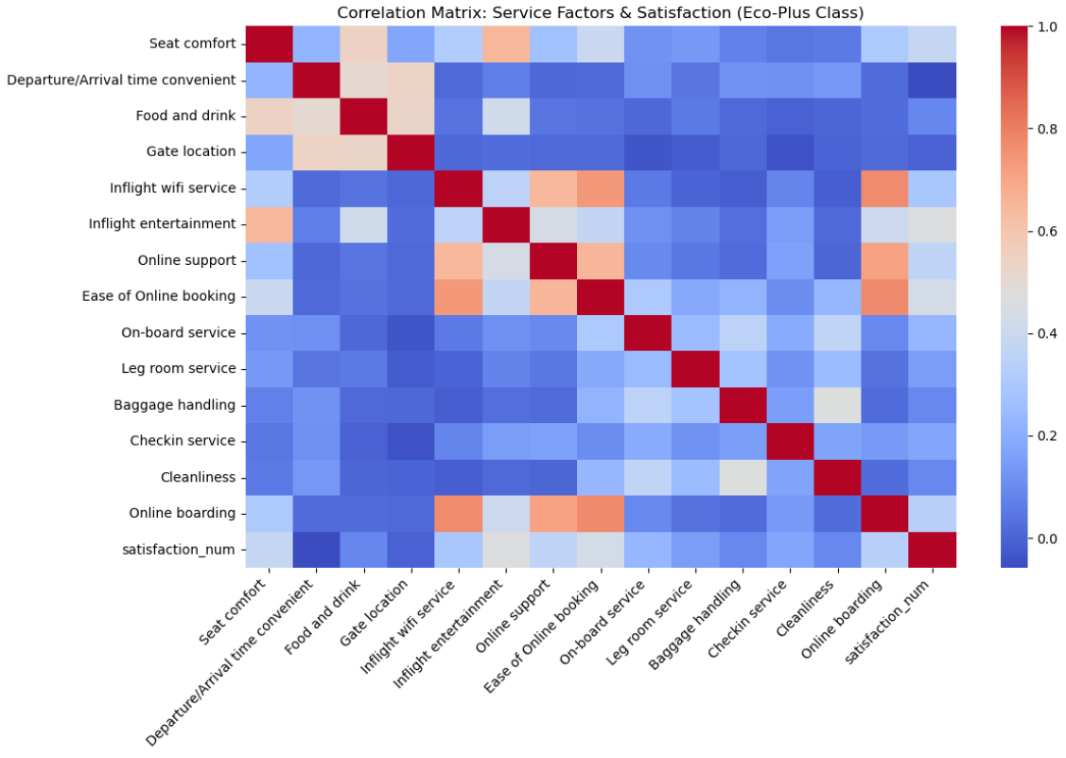
Figure 5
Fig. 5. Correlation matrix for eco-plus class.
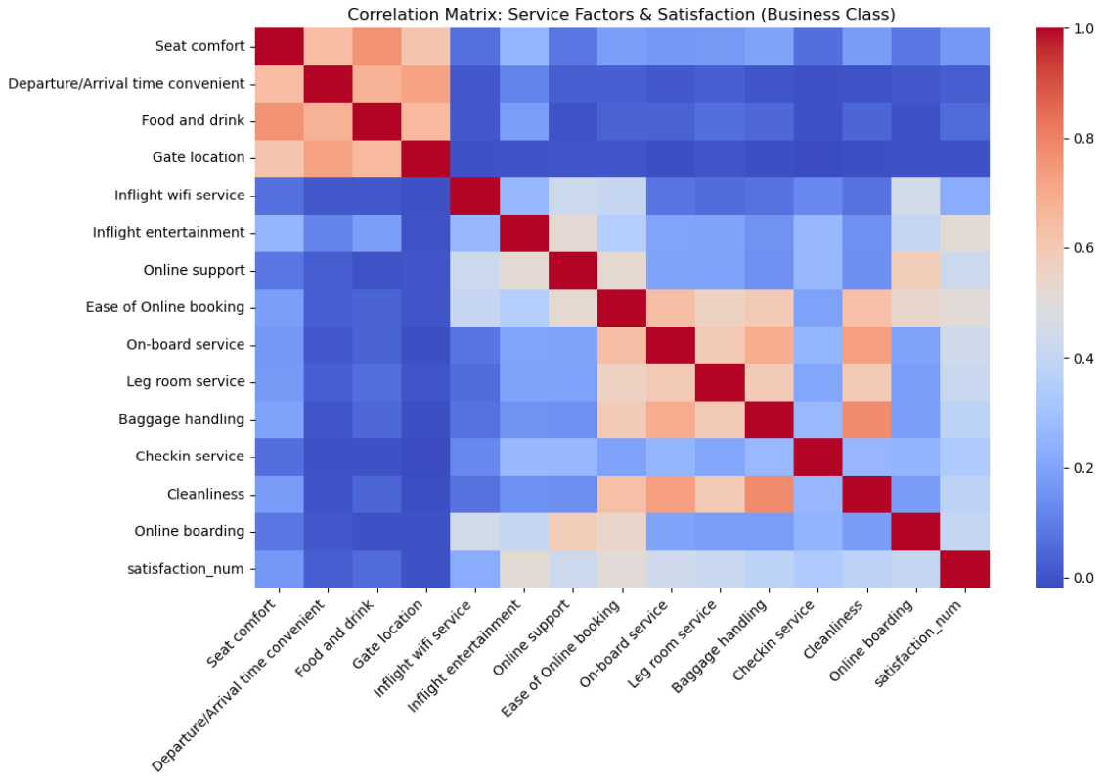
Figure 6
Fig. 6. Correlation matrix for business class.
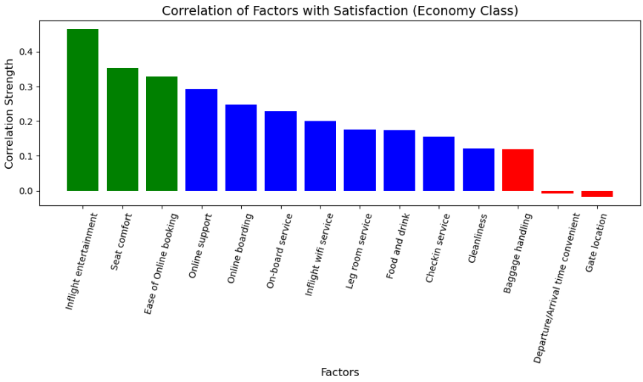
Figure 7

Fig. 7. Bar chart illustrating correlation of factors with satisfaction for economy class. The most influential factors for economy class were in-flight entertainment, seat comfort, and ease of online booking. Online support and online boarding were also influential, indicating that having good digital experiences impacts passengers’ satisfaction.

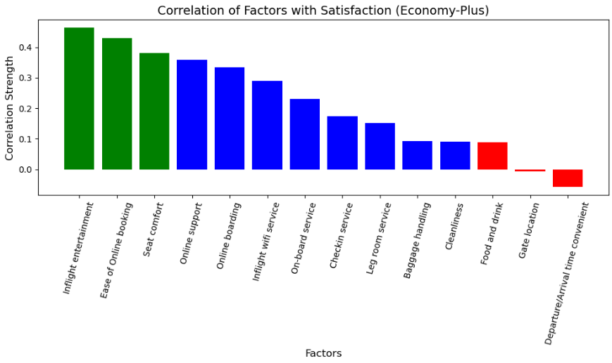
Figure 8

Fig. 8. Bar chart illustrating correlation of factors with satisfaction for eco-plus (economy-plus) class. The most influential factors for the eco-plus class were in-flight entertainment, ease of online booking, and seat comfort. The correlation findings between flight service factors and satisfaction closely resemble the findings in economy class.

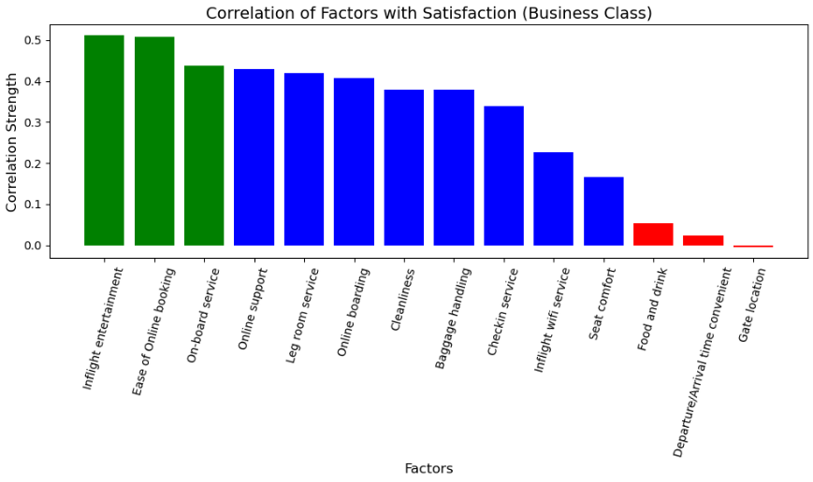
Figure 9
Fig. 9. Bar chart illustrating correlation of factors with satisfaction for business class. The most influential factors for business class were in-flight entertainment, ease of online booking, and on-board service. Most factors here have a higher correlation with satisfaction when compared to economy and eco-plus.
  - Average Service Ratings: Overall Dataset, and for Each Sub-Dataset
Another important component of the analysis involved analyzing the average service ratings for each factor provided by passengers across all flight classes, as well as the overall dataset.
Across the entire dataset, several factors consistently received higher ratings, such as cleanliness, baggage handling, and online support. These strengths suggest that passengers generally view basic operational and cabin services positively. In contrast, other factors such as food/drink, seat comfort, and in-flight Wi-Fi service received lower average ratings, indicating areas where passenger expectations are not being fully met.

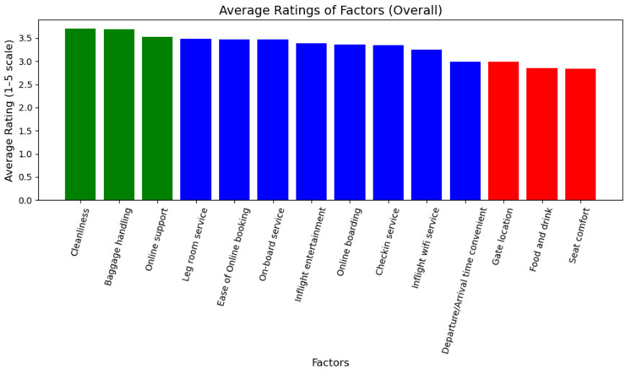
Figure 10
Fig. 10. Bar chart illustrating the average ratings of factors across the entire dataset (overall).
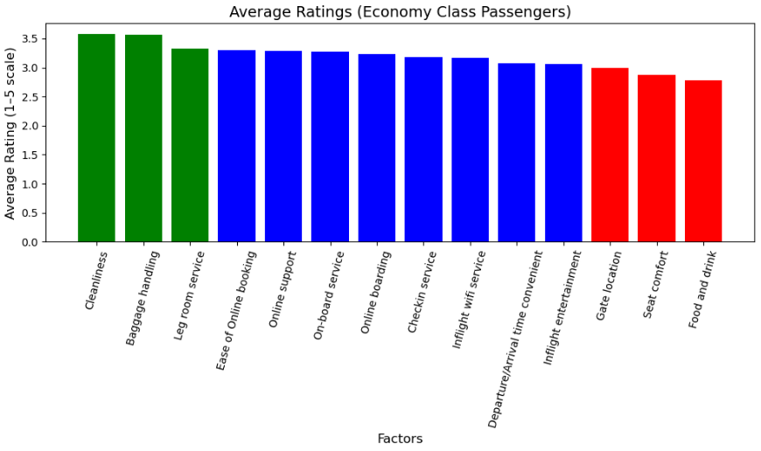
Figure 11
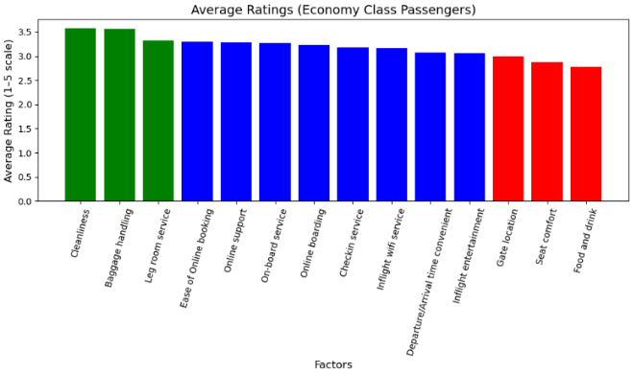

Fig. 11. Bar chart illustrating the average ratings of factors for economy class passengers. Economy class passengers had slightly lower ratings overall, reflecting both the more limited service levels associated with this class and wider variability in passenger expectations.
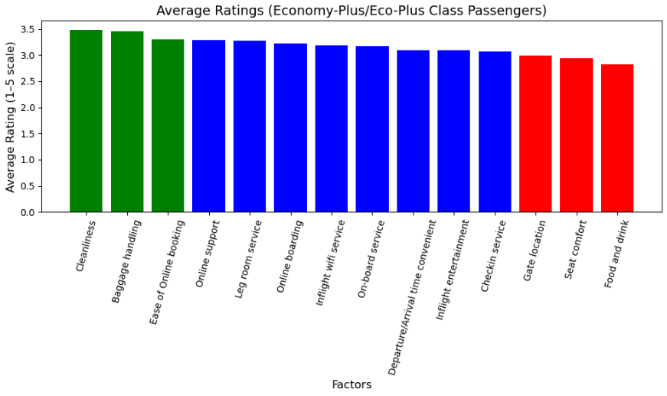
Figure 12:

Fig. 12. Bar chart illustrating the average ratings of factors for eco-plus (economy-plus) class passengers. Eco-Plus ratings were slightly higher than Economy, with improvements in comfort and service consistency, resulting in balanced ratings across most categories.
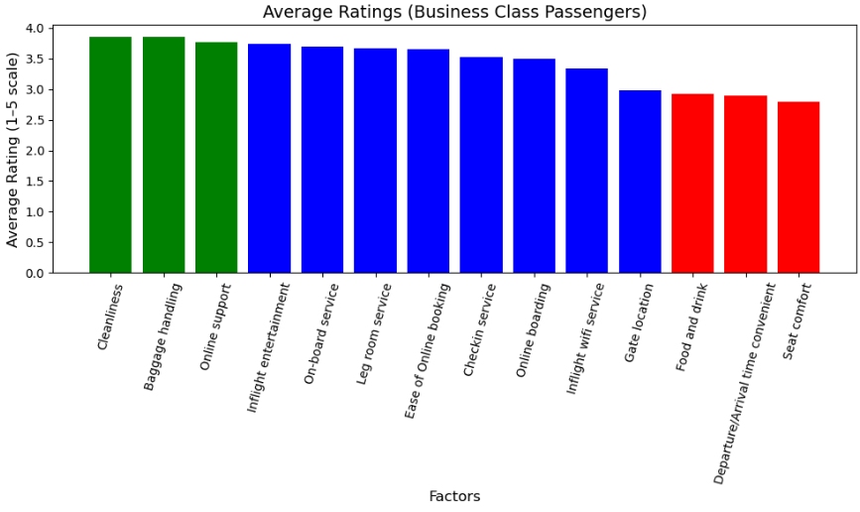
Figure 13:
Fig. 13. Bar chart illustrating the average ratings of factors for business class passengers. Business class passengers gave the highest ratings across nearly all service factors.

  - Decision Tree Analysis
To dive deeper into the analysis, a Decision Tree Classifier was developed using fourteen service factors. The dataset was split into training (75%) and testing (25%) sets, and the model achieved an accuracy of approximately 87%, indicating strong predictive performance. The model’s feature importance results strongly aligned with the correlation findings. In​‍​‌‍​‍‌​‍​‌‍​‍‌ particular, the single most significant predictor of passenger satisfaction was in-flight entertainment, followed by seat comfort and the ease of booking online, which indicates that these factors have a substantial influence on the probability of passenger ​‍​‌‍​‍‌​‍​‌‍​‍‌satisfaction.
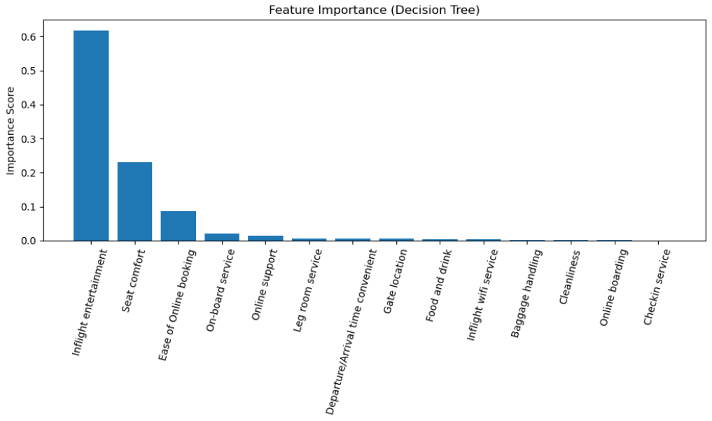
Figure 14
Fig. 14. Bar chart illustrating the strongest predictors of satisfaction, with in-flight entertainment at the top. It is then followed by seat comfort, and then ease of online booking.
A simplified visualization of the decision tree was also developed to illustrate how the model organizes decision rules. The​‍​‌‍​‍‌​‍​‌‍​‍‌ decision tree model showed that in-flight entertainment is the factor that has the greatest impact on customer satisfaction; thus, this feature constitutes the root split of the tree. Moreover, seat comfort, ease of online booking, and on-board service were the significant factors as well, coming up frequently in the top sections of the ​‍​‌‍​‍‌​‍​‌‍​‍‌tree. Seat comfort, ease of online booking, and on-board service were also major factors, appearing repeatedly in the upper sections of the tree. Lower-impact factors such as gate location and in-flight Wi-Fi appeared only in deeper branches, confirming their limited role in predicting satisfaction. Overall, the decision tree visualizes how passengers weigh various service factors and provides a clear hierarchy of priorities that airlines can use to guide service improvements.

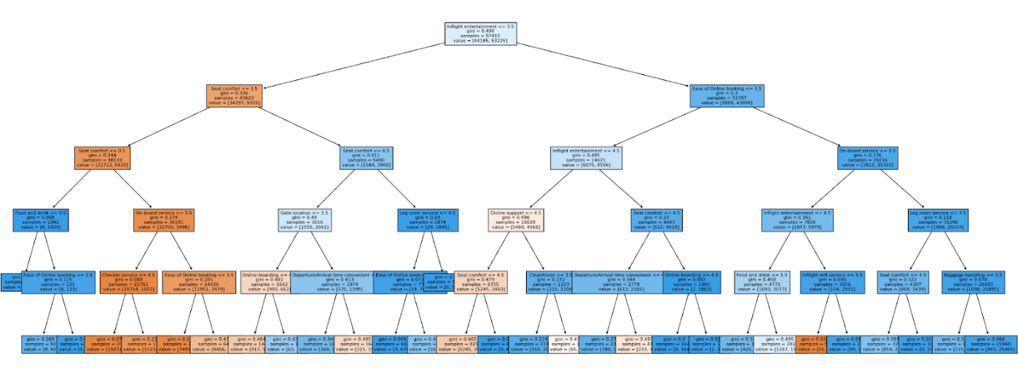
Figure 15
Fig. 15. Decision tree visualization, illustrating the strongest predictors of satisfaction, with in-flight entertainment at the top.
- Discussion
The results from our data analyses indicate that in-flight entertainment, seat comfort, ease of online booking, and on-board service are the most influential predictors of customer satisfaction overall. These​‍​‌‍​‍‌​‍​‌‍​‍‌ findings can be used to pinpoint the exact areas where airlines need to focus and invest their money if they want to elevate the traveling experience of their customers. Since in-flight entertainment and seat comfort are the most influential factors of the customer's satisfaction, it is consistent with the earlier studies that an in-flight experience mainly determines the passenger's perception and behavior (Park et al., 2006; Archana & Subha, ​‍​‌‍​‍‌​‍​‌‍​‍‌2012). Similarly, the importance of having a good digital experience before and during flights aligns with studies emphasizing the growing role of technology and its convenience, as it affects passengers’ evaluations, especially among Economy Class travelers (Chung & Hsu, 2015).
Additionally, the Decision Tree Classifier strengthened the validity of the findings. The​‍​‌‍​‍‌​‍​‌‍​‍‌ model was able to achieve around 87% accuracy when it identified in-flight entertainment as the main factor that leads to satisfaction, the seat comfort and the ease of online booking being the next most important factors. Such findings are similar to those in more recent machine learning research, which showed that service attributes related to convenience and comfort usually have the strongest influence on customer satisfaction (Abdella et al., 2019). Nevertheless, these findings differ from those of some previous studies that only focus on prediction, as the current analyses offer airlines actionable insights, so that they can implement ​‍​‌‍​‍‌​‍​‌‍​‍‌changes.

However, across the travel classes, the analysis and findings show distinct priorities that inform targeted recommendations. For Economy passengers, satisfaction is heavily shaped by digital convenience, suggesting that improvements to online booking, online boarding, and the consistency of on-board service would be effective. Eco-Plus passengers value a balance of comfort and digital efficiency, indicating that improvements to seat comfort, in-flight entertainment, and overall service delivery would help raise and improve satisfaction. Business Class passengers place the greatest emphasis on comfort, including seat quality, leg room, cabin cleanliness, and premium service, making these areas the most important targets for improvement as well as service.
The implications of these findings are significant in terms of practice and policy. To begin with, companies that want to raise consumer satisfaction levels may consider putting money into in-flight entertainment systems, better seating, and simplified, user-friendly digital platforms for booking to ensure these receive the top spots in the average ratings. These areas imply the most considerable potential for service progress as a result of their strong influence on satisfaction and only moderate ratings. Next, the class-based results suggest that airlines should tailor and customize their service-based improvements with each class; e.g. Business Class upgrades may concentrate on making the physical environment more comfortable, whereas Economy Class enhancements may focus on the digital side, being efficient and ​‍​‌‍​‍‌​‍​‌‍​‍‌accessible.
While these class-specific recommendations highlight different priorities, the overall analysis supported by both the correlation findings and the decision tree classifier identifies in-flight entertainment, seat comfort, and ease of online booking as the most influential predictors of satisfaction across all passengers. Therefore, the airline should prioritize broad improvements in these high-impact areas, as they are the main contributors to customer satisfaction overall.
- Conclusion
This​‍​‌‍​‍‌​‍​‌‍​‍‌ project was intended to analyze airline operational performance and customer satisfaction for identifying high-impact service factors and recommending areas of improvement. The approach of the study, including data preprocessing, correlation analysis, comparisons of classes, and a Decision Tree Classifier, brought up very clear and practical customer satisfaction drivers.
The results indicated that the in-flight entertainment, seat comfort, and ease of online booking were the factors that most strongly predicted customer satisfaction overall, based on the analyses utilized. These service factors give concrete examples to airlines of how operations can be improved. Moreover, the analysis brought up the significant differences in travel classes where the passengers in economy were more focused on digital efficiency, whereas the business class passengers gave more weight to the factors related to their comfort, such as cleanliness, legroom, and seat comfort. These differences imply that improvements in the services should be targeted differently for each class to have the maximum effect.
From a business perspective, the outcomes emphasize the worth of putting funds into service features that both directly improve the travel experience and make customer interactions with airline systems easier. For example, making the entertainment systems more attractive, raising the standard of the seating, and ensuring the digital booking system is more user-friendly will yield customer satisfaction, which, in turn, will result in customer loyalty and positive brand perception.
The project displayed a number of strengths, such as the employment of both descriptive and predictive techniques, the utilization of class-specific analyses, and the harmony between correlation and model-based findings. The Decision Tree Classifier, having a high accuracy and interpretability, helped further our analysis for the factors identified as most influential.
There​‍​‌‍​‍‌​‍​‌‍​‍‌ are certain limitations, however, within the project. For instance, the complete analysis hinges on a singular dataset only, which may not be enough to unfold all aspects of the airline operations and the customer demographics. Additionally, certain service factors like staff behavior and pricing, which were not present in the dataset, may have a very strong impact on customer satisfaction. Moreover, the study has been predominantly focused on operational and service-related ratings; hence, the next analysis could extend the consideration of factors such as route length, aircraft type, loyalty programs, and real-time operational performance metrics. Researchers can also use more advanced models like Random Forests or Gradient Boosting to compare their predictive performance and further clarify the importance of the ​‍​‌‍​‍‌​‍​‌‍​‍‌variables.
To conclude, this project effectively identified the factors with the greatest impact on airline customer satisfaction and served as the basis for data-driven decision-making. Airlines may not only improve their overall service quality and increase customer loyalty through this, but they may also be able to withstand the pressure of the ever-intensifying competition in the airline ​‍​‌‍​‍‌​‍​‌‍​‍‌industry.
References
Abdella, G. M., Mohamed, A. B., & Abdou, A. (2019). Airline passenger satisfaction and loyalty: A machine learning approach. International Journal of Machine Learning and Computing, 9(2), 129–134. https://doi.org/10.18178/ijmlc.2019.9.2.778
Archana, R., & Subha, M. V. (2012). A study on service quality and passenger satisfaction on Indian airlines. International Journal of Multidisciplinary Research, 2(2), 50–63.
Chen, F.-Y., & Chang, Y.-H. (2005). Examining airline service quality from a process perspective. Journal of Air Transport Management, 11(2), 79–87.
Chung, H., & Hsu, C. (2015). Predicting airline customer satisfaction using machine learning techniques. Journal of Air Transport Studies, 6(2), 161–175.*
Oliver, R. L. (1980). A cognitive model of the antecedents and consequences of satisfaction decisions. Journal of Marketing Research, 17(4), 460–469. https://doi.org/10.2307/3150499
Parasuraman, A., Zeithaml, V. A., & Berry, L. L. (1988). SERVQUAL: A multiple-item scale for measuring consumer perceptions of service quality. Journal of Retailing, 64(1), 12–40.
Park, J.-W., Robertson, R., & Wu, C. (2006). Modelling the impact of airline service quality and marketing variables on passenger satisfaction. Journal of Air Transport Management, 12(6), 387–392.

